Lab 8 Logs
Ex1
#include <stdio.h>

int main()
{
int x[5]; /* declare array x to contain 5 integers */

/* Assign values to array x */
x[0] = 1;
x[1] = 2;
x[2] = 3;
x[3] = 4;
x[4] = 5; /* note max index is 4 (size – 1) */

/* Display values from array x */
printf("x[0] = %d\n", x[0]);
printf("x[1] = %d\n", x[1]);
printf("x[2] = %d\n", x[2]);
printf("x[3] = %d\n", x[3]);
printf("x[4] = %d\n", x[4]);

return 0;
}

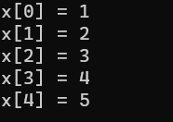

Ex2
#include <stdio.h>

int main()
{
int i;
int x[10]; /* declare array x to contain 10 integers */

/* Assign values to the array x */
for(i=0; i < 10; i++)
{
x[i] = i + 1;
printf("x[%d] = %d\n", i, x[i]);
}

return 0;
}
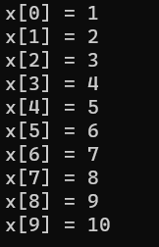

Ex3
#include <stdio.h>

int main() {
int size_of_array = 10;
int x[10] = {0}; /* initialise all elements of array to zero */
int i;

/* Ask user to enter 10 numbers */
printf("Enter 10 numbers\n");
for(i = 0; i < size_of_array; i++) {
printf("Enter a number: ");
scanf("%d", &x[i]);
}

/* Display values in each element of array x */
for(i = 0; i < size_of_array; i++) {
printf("x[%d] = %d\n", i, x[i]);
}

return 0;
}
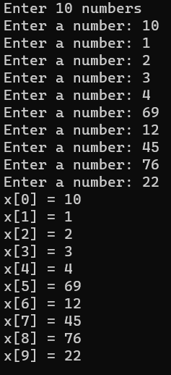

EX4
#include <stdio.h>

int main() {
int size_of_array = 10;
int x[10] = {0}; /* initialize all elements of the array to zero */
int i;
FILE *input_fptr;

/* Open file for reading */
input_fptr = fopen("input.txt", "r");

if (input_fptr != NULL) {
/* Read 10 numbers from the file */
for (i = 0; i < size_of_array; i++) {
fscanf(input_fptr, "%d", &x[i]);
}

fclose(input_fptr);

/* Display values in each element of array x */
printf("Values in the array:\n");
for (i = 0; i < size_of_array; i++) {
printf("x[%d] = %d\n", i, x[i]);
}
} else {
printf("Error – could not open the file\n");
}

return 0;
}
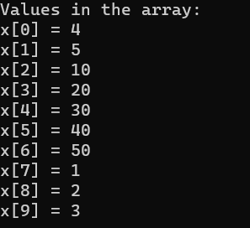

Ex 5
#include <stdio.h>

int main() {
int size_of_array = 10;
char ch[10] = {0}; /* initialize all elements of character array to zero */
int x[10] = {0}; /* initialize all elements of integer array to zero */
int i;
FILE *input_fptr;

/* Open file for reading */
input_fptr = fopen("input2.txt", "r");

if (input_fptr != NULL) {
/* Read 10 pairs of character and integer from the file */
for (i = 0; i < size_of_array; i++) {
fscanf(input_fptr, "%c %d\n", &ch[i], &x[i]);
}

fclose(input_fptr);

/* Display values in each element of both arrays */
printf("Values in the arrays:\n");
for (i = 0; i < size_of_array; i++) {
printf("ch[%d] = %c\n", i, ch[i]);
printf("x[%d] = %d\n", i, x[i]);
}
} else {
printf("Error – could not open the file\n");
}

return 0;
}
